mHealth - A technology driven approach for digitizing health monitoring by mobile applications in India.

submitted on September 30, 2022, in partial fulfilment of the degree-awarding conditions.

 MSc in Health Informatics

Supervisor. :- Dr Ikram Ur Rehman

School of Computing and Engineering

The University of West London

I certify that everything in this dissertation report is my own work.

Copyrights: -

The author owns the copyright to this dissertation within the rules of the UK Copyright Act as amended by the University of West London regulations. Any use of materials from this thesis or that come from it must always be credited.

Acknowledgement: -

 I myself would mention here to thank these following people who have helped me to fulfil this research topic.

*Dr Ikram Ur Rehman*, my supervisor, for his enthusiasm, help and patience during the project;

School of computer and engineering university of west London for throughout my Msc programme.

For contributing their effort in data collection and research study.

*-Mr Prashant vora*, Tata Consultancy Services Limited UK

*-Mr Satish bhalara* , Health one INC. surat

*-Mr Chitrarth parghi (CA, ACS, CFA)*, Aethar industries limited (Surat)

*-Mrs Itee Pattani (CFA)*, Ting- Mumbai

The kind friends and family members of mine who took their generous interest to fulfilling the survey questionnaire.

And to my parents who set me off the road to this MSc a long time ago.

# Abstract:

Mobile health, often known as mHealth, is the provision of medical assistance through the utilisation of smartphone innovations in order to improve patient welfare. As per estimates provided by Grand View Research, the global mHealth market is expected to generate a stunning $49.12 billion in sales by the year 2020. Modern technology is rapidly allowing the medical business and mobile health everywhere around nation by enhancing how data is protected, shared, and retrieved. This is happening across the globe. In India's hospitals and clinics, patient records, health sharing of data, and digitally remote patient monitoring are already becoming mainstream; nevertheless, mobile healthcare innovations have been embraced by very individuals*. (Nurgalieva, O’Callaghan and Doherty, 2020)*

Individuals typically keep their cell devices on companions throughout the day and are eligible to obtain push notifications because there is neither consistent interconnection nor technology impacted. As a result, conversation is a strategy that is both remarkably efficient and relatively inexpensive. One of the mhealth projects in India renowned as mDiabetes is a good indicator of the effectiveness texting. mDiabetes is a mobile data curriculum that was carried out between the one million people in India with the goal of encouraging individuals to eat healthily and reduce the behaviours that put them at risk for developing diabetes. According to the findings of a study that was recently issue of the journal of healthcare and computer research, those participants who got the push notifications had a greater awareness of the issue and problems of diabetes, a disease that affects over 70 mn indigenous people. At the end of the study period of six months, participants who had received the SMS messages started eating more healthily. three In point of fact, Hitachi has developed a virtual diabetes prevention programme that makes use of healthcare data tools to determine insights, wearable electronics, and remote machine learning coaching in order to provide scalable and tailored Mhealth options to meet meaningful way of life goals. In addition to mobile phones, computerisation (ICT) plays a big part in the improvement of healthcare technology in India. ICT offers an effective method of acquiring, changing, and storing data, which is one of the reasons why this technology is so important. The Internet of Things (IoT) in medicine and healthcare records analytics provide a seamless patient experience by providing cost-effective treatments through utilisation of information gleaned from medical, physiological, electromechanical, and contaminants. In addition to this, it helps contribute to the process that builds bridges among practitioners and the customers that they represent, even between scientists in the fitness industry and clinical practitioners. For instance, when a service user attains a tropical ailment while going abroad and indeed the local medical provider has been unable to make a diagnosis it, the client may use ICT to quickly explain the early signs with healthcare professionals’ locations all over the world. This is possible because of the global nature of the internet.

mHealth is the next step in the evolution of ICT in healthcare. The current state of mHealth systems and the findings from the most recent studies on the major mHealth service providers in India and their contribution to the impending revolution in the digital healthcare industry in India are discussed in this paper. With smartphones and other mobile devices that utilise sensory technology becoming increasingly commonplace, mHealth has been the subject of rapid innovation. Online shops reflect the booming demand for mobile apps by stocking thousands of programmes that may be downloaded and installed on a mobile device. From the results of data analysis gathered from the active survey participants, it may be determined that usage of mobile health applications for health data monitoring was effective in India despite the scope of innovation in this respective field.

Keywords: mHealth, communication, technology, healthcare, analytics, survey, smartphone.

Table of Contents

Abstract: 2

Introduction 5

2) Historical context: 8

AIM: - 9

Objectives: 9

Literature review: 10

Theoretical foundations: - 10

Methodology: - 12

Data collection and analysis: 13

Ethics: - 13

What is the application? 14

The Architecture of the Mobile Health System: - 14

mHealth application adaptation in India: - 16

Variation in market opportunities: 18

Impact of mHealth applications: - 19

Cost savings in healthcare: - 21

Improvements in Healthcare Delivery Efficiency and Speed: 21

Barriers and drawbacks for mHealth applications: 22

Service and hardware costs as a percentage of take-home pay: 23

Discussion and Results: - 23

Findings and recommendations: - 29

The project's constraints: - 30

Future works: 30

Conclusion: 31

Appendices: 33

References: - 35

# Introduction

mHealth is often seen as the delivery of healthcare services or knowledge by using a cell device. material. The services are currently offered on a global scale. There is a wide range of intelligence levels across different marketplaces. They often provide static information regarding a specific ailment or illness, and others go significantly up the value chain by providing entire health monitoring. It is beyond the scope of what could be accomplished through direct personal contact alone with a physician or other medical professional.

Contemporary improvements in information and communication technology (ICT), specifically mobile phones, have pervasively aided our day-to-day lives. During the last decade, smart cellular smartphones have advanced as one of the most outstanding consumer electronic objects. Exploring and comprehending the aspects that would impact the acceptability of the modern cellular era has consequently become a vital obligation for cellular device companies and distributors. Phablets, which combine the functionality and capabilities of both pill desktops and clever telephones, have regularly emerged as possible alternatives to smart phones. *(Nunes, Limpo and Castro, 2019)*, As a result, identifying factors that may influence Phablet acceptability has become critical for developing, manufacturing, and marketing such mobile devices. Such projections, however, are hard to make. In the meantime, only a few studies have attempted to investigate related issues. As a result, scientists need to research and forecast tablet usage intentions. *(Ma and Liu, 2022).* In recent years, clever mobile device improvements have had a great influence on client conduct, existence, and the enlargement of the digital region. As a result, marketers and designers ought to recognise and research the important components that can impact the adoption and non-stop utilisation of clever cell devices with the purpose of allowing such devices to reach similarly and satisfy customers' expectations. *(Nunes, Limpo and Castro, 2019)*The sector health enterprise today described mHealth as "the use of cell and wi-fi technologies to aid the success of fitness objectives."   
mHealth is defined by the National Institutes of Fitness (NIH) as "the use of mobile and wi-fi gadgets (cell phones, pills, and so forth) to enhance fitness consequences, health care offerings, and fitness studies."

Past exams on era adoption can be labelled into two classes: firm-degree troubles and individual-level troubles. On the other hand, look at business-level issues such as how employees within the company investigate usage happiness and worth in relation to the adoption of a brand-new generation in process strategies. Individual degree, on the other hand, examines confirmed how users or consumers evaluate happiness in relation to the adoptions and usages of a single era of their lives from the dimensions of perceived ease of use and cost, and so on.

Over two-thirds (66%) of consumers in advanced countries use cell applications to regulate their health, and approximately 105,000 mobile fitness (mHealth) apps are already available in the Apple iTunes and Android app global stores. Many mHealth applications are designed or advanced with minimal customer feedback and continue to proliferate despite limited evidence supporting app user engagement. Only 4% of mHealth apps offering breast-feeding help, for example, had any data supporting their efficacy. Apps are frequently created with poor design and no attention to end-user desires. mHealth (sometimes called m-health or MHealth) , cellular health is a phrase that is used to define the treatment of medicines and social wellness that is helped by mobile phones. The acronym ch stands for "cellular health." *(Siegler et al., 2021)* The term is most used to refer to the use of wireless transmission electronic devices such as smartphones, personal computers, and netbooks (PDAs), as well as fitness trackers such as activity trackers, for the purpose of providing health services, information, and record keeping. The mHealth industry has developed as a subset of digital health, which refers to the utilisation of communication and information technology (ICT) for the purpose of providing health services and maintaining patient records. Examples of ICT include personal computers, mobile phones, communications satellites, patient video display devices, and so on.

mHealth (or m-health) is an abbreviation for mobile fitness, which is the education of medication and health care via cellular gadgets, including drugs, PDAs, and computer systems.   
The mHealth industry has grown exponentially in recent years as a result of full-size use in developing countries and an increasing number of available cellular generations.   
Many human beings are familiar with eHealth, which is a department of healthcare that employs computers, emails, satellite TV for personal computer communications, and video display units.   
mHealth technology works the same way on tablets, cell phones, and other portable devices. It can collect important signs and symptoms, send information to doctors, and allow for remote assessments.--

mHealth (or m-health) is an abbreviation for mobile fitness, which is the education of medication and health care via cellular gadgets, including drugs, PDAs, and computer systems.   
The mHealth industry has grown exponentially in recent years as a result of full-size use in developing countries and an increasing number of available cellular generations.   
Many human beings are familiar with eHealth, which is a department of healthcare that employs computers, emails, satellite TV for personal computer communications, and video display units. mHealth technology works the same way on tablets, cell phones, and other portable devices. It can collect important signs and symptoms, send information to doctors, and allow for remote assessments.

A cell smartphone is a multipurpose and powerful day-to-day capable of performing a number of tasks that are beyond its primary purpose of communication. There is lots of hype around cellular technology, especially smartphones, and a number of new and revolutionary functionalities and/or apps that are capable of addressing wishes in new regions are being released daily. People have commenced using cellular phones for a hugely wide variety of activities—banking; shopping; speaking; looking at games, movies, and motion pictures; being attentive every day; surfing for news, tour information, etc. The effect of the mobile generation on our lives is clearly developing each day. Smartphones and mobile apps are an effective aggregate that has made it very smooth and handy day-to-day to carry out numerous habitual everyday complex tasks. Cell generation is making big inroads even in the healthcare space. mHealth (or mobile health) is generally defined as the provision of health offerings through cellular technologies. mHealth is set to leverage cell and wireless gadgets to improve fitness outcomes. The carrier can be as easy as the use of the mobile’s SMS function day-to-day to send indicators and reminders or leverage in-built mobile sensors or apps every day to capture and interpret clinical statistics. It is anticipated that mHealth will have a substantial impact on the healthcare environment in India, just as it has had a significant influence on the healthcare environments of other emerging nations. This technology may raise the efficiency of healthcare professionals in India while also reducing the expenses of providing medical care and improving access to medical services. However, a number of obstacles are preventing mHealth from having a significant impact on the Indian healthcare sector.

The programmes may or may not function from a clinical and technological standpoint. A potential user has no way of knowing which applications can be relied on. The number of downloads is a metric, but it is no longer a reliable one because most mHealth apps are unable to keep their clients. Furthermore, most mHealth app reviews are generated by users within the app store. As a result, evaluations are often dependent on personal impressions. Cellular site traffic is rapidly increasing year after year and is expected to increase more than sevenfold between 2016 and 2021, both internationally and in India. Indians are spending more and more time on their cell phones. A typical Indian spends about three hours per day on his or her phone. The mobile era has the potential to impact many aspects of our lives, including exercise and health*. (Ventola, 2014)*

More than 1.5 million mHealth apps are available on the iTunes and Android global app stores. four Many mHealth apps are built on weak ground and are thrown away with the help of the developer after a first release or one update.

Tata-1mg is a popular Indian online pharmacy with 50 million monthly customers who provides access to doctor consultations and drug information. It’s a classifies customer-generated search phrases with the assistance of clinical practitioners based on their link with disease and severity, and then they evaluate their correlation with reported overall prescribed report counts for Indian cities.

# 2) Historical context:

The cell health region couldn't have existed earlier than the improvement of the first cellular cell phone. In 1949, AT &T set up a programme known as Mobile Smartphone Provider, which later improved to a hundred communities and 5,000 customers. Unfortunately, technological obstacles averted this initiative from spreading across the country. At any given second, the most effective three radio channels were reachable, which supposed that at any given second, the most effective three customers ought to call any metropolis on the planet. As time passed, mobile phones grew more ubiquitous, and businesses such as Apple and Samsung produced complicated smartphones, which fuelled the development of mobile health applications for users worldwide.

The mobile health market is expected to rise to about $23 billion by 2022, with nearly half of physicians currently using mobile health applications on a daily basis. Right now, the push for interoperability should make mobile health efforts more effective because more mobile health devices and apps will be able to share information with each other. policies and laws on cell fitness are currently influencing the way this perception is modernising the healthcare career.

The lack of mHealth coverage has created a giant false impression amongst providers, and virtual fitness companies are harassed by whether authorities have authority over their goods or services. The wearable era is having a significant impact on the healthcare industry and the mobile health movement. The Leaf device, for instance, is a lightweight and wearable sensor that remotely tracks a patient's movements. The sensor is connected to cellular devices, which notify caregivers of any adjustments in a patient's posture or movement. As the MHealth enterprise grows within the future years, the skills of smartphones as well as mobile health applications will certainly have an influence on the healthcare profession and decorate patient care across the country. (arman, n.d 2019)

Many components of medical guidance have been altered because of fitness care professionals' (HCPs') usage of mobile devices. Smart phones have ended up ubiquitous in clinical placement, resulting in a surge in the creation of clinical software programmes (apps) for those structures. 1, 2 At the moment, there are numerous apps to be had to assist HCPs with a spread of essential responsibilities, such as records and time management, health file upkeep and getting right of entry to, connectivity and consulting, reference and intelligence collection, patient control and monitoring, healthcare selection, and scientific education and schooling. *(delloite, n.d 2019).*

Mobile devices and programmes offer several advantages to HCPs, the most exceptional of which is accelerated access to factor-of-care equipment, which has been observed to help with higher medical judgement and patient outcomes. But a few HCPs are nonetheless hesitant to use them.   
Regardless of the advantages they provide, stepped-forward standards and validation strategies for cellular medical applications are required to permit accurate usage and integration of this increasingly complicated equipment into medical training. These initiatives will enhance the entrance barrier into the medical app enterprise, thereby improving the quality and safety of the applications now accessible for usage with the aid of HCPs.

# AIM: -

Researchers in this article investigate the state of mobile health app uptake in India.

The main goals of this research are to compare and contrast males and females, age groups, and different generations in terms of adoption.

The study aims to accomplish the following:

This project will demonstrate the effectiveness and adoption of mobile health applications in India and the United Kingdom. These two countries have been chosen as the researchers have been using and have experience of using mobile health applications in India and the United Kingdom. The findings will be demonstrated of the current adoption and utilisation environment of mobile health applications in different age groups.

# Objectives:

* To learn more about how successful mobile health applications are in traditional health check-up consulting,
* This is a full-proof opportunity to raise awareness of the problems associated with using mobile health applications for health consulting and medical usage.
* To suggest an effective process for achieving better results by using mobile health applications for better health consultation and treatment.
* To find out if participants are happy with the outcome and their interactions with the mobile health application and health consultation,
* To teach the readers about the problems that participants face when using applications and consulting because of technical problems.
* The goal of this study is to compare the success rates of mobile health applications in India with those in the United Kingdom.

# Literature review:

In the sections before this one, we looked at what mobile health and electronic health mean, how mobile health is used in India, and how other countries are using digital health to improve care.

In addition, the advantages and disadvantages of the factors that influence the adoption of mobile phones for health-related services were highlighted. This chapter offers an overview of the theoretical and empirical background as well as the identification of research gaps, which are structured as follows in the following paragraphs: The following section serves as the theoretical foundation for this research.

# Theoretical foundations: -

To comprehend the hypothesis underlying mobile health, the foremost theories concerning media selection and use, technology adoption, and health belief models must be examined. This section offers a review of selected literature, uncovering people's use of systems to meet the needs described ahead.

Its technological innovation process is a sociocultural framework that is an outgrowth of a concept that was originally developed for the phase transition by Joe M. Bohlen, George M. Beal, and Everett M. Rogers (Bohlen et al. 2019). According to Rogers (2003), the spread of new technologies happens when individuals and methods move along through the phases of the invention decision-making process, which are knowledge, persuasion, decision, implementation, and confirmation. When the affirmation phase is over, participants will have a clear understanding of their own decisions regarding the extent to which they will continue to use the technology. The idea that software can be "domesticated" is another lens through which the design of the capillary forces that account for acceptance, rejection, and use can be investigated. It identifies the process of domestication through the dimensions of appropriation, objectification, incorporation, and translation, each of which eventually results in the provision of destined attribute use or conversation. In the context of medical systems, the concept of "interbreeding" refers to the method by which a physiological basis is incorporated into a device for the purpose of resolving issues facing both the physician community and specific patients.

Tata-1mg is among the leading internet healthcare platforms in India, and users are able to search for and place orders for both prescription and over-the-counter medications on this platform. During the second wave, India experienced a severe shortage of even commonly used medications like paracetamol in the country's local pharmacies [19]. As a result, online healthcare brands such as Tata-1mg saw an unprecedented increase in customer base of more than 80% between January 2021 and June 2021.Consumers are more frequently utilising online healthcare businesses to compile a list of medicines and to place orders for medicines, including essential ones that are not readily available in their immediate area. The business operates eight major distribution centres dispersed throughout India, all of which are geared toward serving both emergency and broad-sense immediate high-quality medical operations from across the nation. *(S, 2020)* At Tata-1mg, one of our primary goals is to stock our distribution centres in a proper manner. It makes it possible to prevent running out of stock, which would result in a loss of market demand and to keep inventory-related costs, such as holding fees, fuel costs, and warehousing costs, within normal limits. The development of improved estimation methods and the identification of early warning signs through changes in user query string are both beneficial techniques that can be utilised to stock an appropriate quantity of opioids that can save lives. It is also possible to conduct diagnostic lab tests and online consultations with medical professionals. These procedures provide data on the percentage of people in a region who test positive for COVID-19 and details on the disease process premised on the health history. With around 50 million unique active users each month across India, the pharmaceutical network has a sizable user base from which to draw conclusions and continue expanding. As a plus, Tata-1mg delivers to over a thousand different cities across India, from the most populous to the least. Based on this background knowledge, this article examines the correlation between distinct groups of search terms (reflecting various disease phases) and the official Covid-19 cases. To demonstrate that the data on search trends can be used as an early indicator of the contagion and to notify the government of the growing demand for drugs, This would be another piece of information that would help stock warehouses across the country with the right number of pharmaceuticals for places with growing backlogs, thus making up for the shortfall.

From the study conducted by (Holdener, Gut and Angerer, 2020) The number and variety of Portable Health (mHealth) applications for use in clinical and consumer settings have grown exponentially in recent years. Concerns concerning dependability, protection, governance, and incorporation are compounded by the rapidly expanding number of health information, leading to a state of confusion among users and healthcare professionals. Scholars, consumers, and care providers are unable to keep up with the rapid pace at which new mHealth apps are being produced and their myriad uses.

After reading about their operation reach in India, it can be seen that the western and southern areas of the country have a significantly larger advantage over the country's northern and eastern regions. This is because the early stages of the current phase, which occurred in March, impacted sections of Maharashtra and Kerala (west and south regions). There was a disruption in the disease pattern as a result of migration, the spread of the disease, and greater transit from these early affected sections to the later impacted regions. After initial indications in the Western and Southern areas, the lockdown was quickly enforced everywhere else. As a result, the unpredictable nature of the sickness may have been altered, and the heightened media frenzy may have accounted for the lower leads and regional disparities in behaviour.

The provision of care in urban areas mHealth with a revolutionary twist Surveillance System People living in cities, particularly some at different income levels, represent an entirely new and distinct potential market. A consultation at a care setting is not as challenging of a task as going to the doctor's office, and regular checks are a reasonable expectation. Consumers, meanwhile, are occupied, and going even a short distance might be an inconvenience. It's not always easy to get around when the city is crowded*. (Smith, 2018)*

Providing mobile quality healthcare, like patient registration via the phone, amongst others, and text message medication refill services, which save customers' time and make supply more convenient. Users are informed that professional services are accessible by means of discussions through cell phones or 4G video calling. Just the tap of a button on your smartphone away. The provision of services highlighting collaborations between reputable medical service providers and organisations that enable technological advancement is expected to translate into higher value when considered. *(Holdener, Gut and Angerer, 2020)*

Accessing a large consumer base and a network of telecommunications companies (or "telcos"), they are ideally positioned to play a pivotal role in the delivery of mobile health care. Everything from providing stable internet connections to overseeing by providing seamless end-to-end service, telecommunications companies can boost the level of services provided for a variety of industries. Healthcare services that can be accessed via mobile devices.

# Methodology: -

Using Google Forms, the collection and analysis of data using a quantitative descriptive approach is part of this research. After the survey's findings are determined, examined, and conclusions drawn, recommendations are discussed ahead.

## Data collection and analysis:

The purpose of this research, which is a quantitative descriptive study, is to ascertain the efficacy of justified adoption of cutting-edge online pharmacy and health consultation using mobile health applications in India and the United Kingdom. Based on prior studies, problems and potential solutions to online health consultation and consumer healthcare were also highlighted. In this study, descriptive research was used to collect quantitative data from a survey conducted on different age group participants. The participants themselves filled out the survey for this study, so their responses are our major source of information, which has been used for generating a clear outcome.

The questionnaire was developed in accordance with the development's stated goals and objectives (survey questions can be found in an appendix). Participants, both male and female, in India and the United Kingdom, participated in a survey that was created and distributed using Google Forms. The link to the poll was distributed to participants by email, the messaging app WhatsApp, word of mouth, and the email client Outlook.

In all, the survey consisted of 11 inquiries and was carried out on an international scale. Several participants who encountered the optimised use of mobile health applications expressed an interest in taking part in the survey. Although the time limit for collecting replies was 20 days, a total of 21 responses were received in the first ten days. Participants from both India and the United Kingdom filled out the survey out of sheer curiosity, and their responses were posted on the Google Data Analytics studio for everyone to see.

Data was collected and shown using Google Forms when the survey was completed; respondents' responses were shown in a pie chart, bar graph, and other forms of visualising data.

# Ethics: -

No ethical snafus were encountered during this project's survey administration. Consent from both the supervisor and the surveyed individuals is required during data collection. All individuals voluntarily participated in this study; no private information was taken, and no one was coerced into answering any questions. Everyone involved is over 18 and has a diagnosed health condition. Participants' personal information was safe because the survey link was delivered to them over reliable channels like Link Collaborate, Gmail, WhatsApp, and Outlook.

Participants who do not wish to disclose personal information, such as their age or gender, are not obligated to do so. This allows them to choose a silent preference like "Prefer not to say." Individuals are free to respond to the survey as they see fit. A lack of articulable choices for the other questions allowed the surveyed to respond confidently.

Mobile applications for healthcare professionals as a two-way prospectus:

### What is the application?

The increasing availability and quality of medical software programmes, or "apps," has aided in the speedy integration of cell gadgets into scientific education. Apps are software programmes designed to run on a laptop or cell device to attain a positive mission. The introduction of a flood of clinical cell device apps for expert and private utilisation has prepared the way for the introduction of a flood of clinical cell device apps for the introduction of a flood of clinical cell device apps. *(Amer et al., 2022)*

The growing availability and satisfactory of scientific software programs, or "apps," has aided in the speedy integration of cell gadgets into medical exercise. Apps are software applications designed to run on a computer or mobile device to accomplish a certain task.   
Quicker processors, multiplied memory, smaller batteries, and particularly green open-supply systems capable of performing complicated sports have organised the way for the creation of a flood of scientific mobile device apps for professional and personal use.

# The Architecture of the Mobile Health System: -

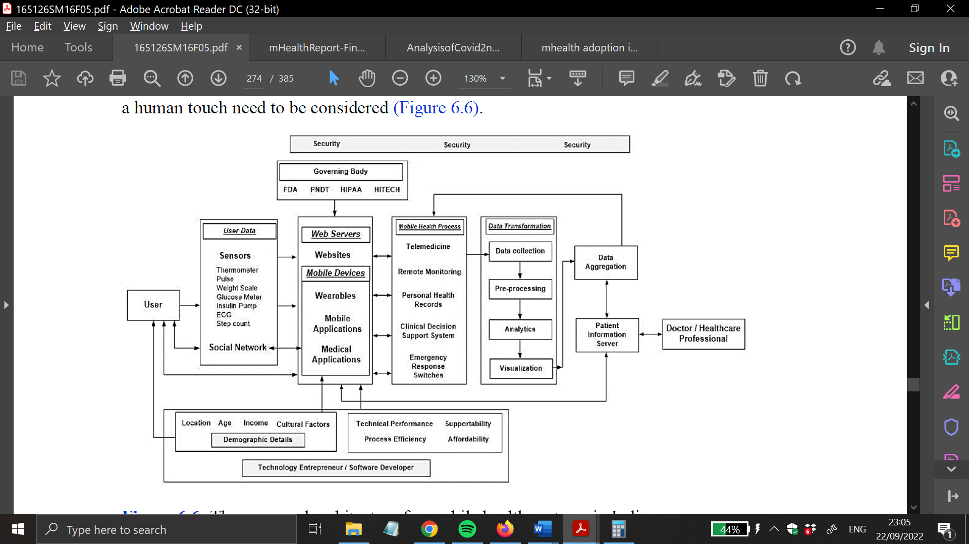

*Figure 1. The framework that is being considered for mobile healthcare systems working in a technical manner.*

In the next part, we will go through the duties and responsibilities that are associated with the various elements that are shown in figure 6.6.

* **Data Streams from Users:** The information can also be gathered through the use of sensors and social networks on Web servers and mobile devices covered in this section. These data should be regulated and approved by the specific governing bodies such as the Food Safety Standard Authority of India (FSSAI), the Healthcare Information Technology for Economic and Diagnostic Health (HITECH) Act, the Health Insurance Portability and Accountability Act (HIPAA), and the Pre-Natal Diagnostic Techniques (PNDT) in order to ensure that the patient's data is protected and only authorised individuals have access to it. Concurrently, the producers of the devices should also take into account their technical performance, supportability, process efficiency, and cost considerations in order to achieve reasonable quality performance In light of the fact that the majority of India's population lives in rural areas, those responsible for the development of mobile health apps and services ought to take the users' demographic characteristics, including location, age, income, cultural elements, and so on, into consideration.
* **Mobile Health Processes:** This refers to the use of a wide range of mobile devices for the purpose of providing medical services. It acts as a way for people to talk to each other and delivers a relevant resolution based on the raw data.
* **Data Transformation:** During this stage, the raw data will be subjected to well-known algorithms, statistics, (Das and Sil, 2019) and visualisations in order to provide a straightforward and straightforward understanding of the patient's health cases, suggesting prescriptions and treatments.

These data are then aggregated and stored in the patient information server after being translated into a useful solution via the aforementioned channels and various mobile health processes (telemedicine, health and wellness, and so on). Because this information is stored in the cloud, the user or a healthcare professional can access it by providing the necessary login details and selecting the appropriate file. The implementation of evidence-based practise and education are both helped forward by this.

The key criterion for app choice is often cost; consumers may additionally choose to download a free software programme, but may also, sooner or later, if required, switch or update it with one that charges cash. Some free applications are absolutely functional, at the same time as others are inoperable or at best partly useful until you pay for a subscription. Numerous scientific periodicals and textbooks can be received as phone packages after paying a subscription price. Although positive clinical packages can be pricey in the beginning, they can ultimately be valuable if updates are provided. *(Lipscomb et al., 2021)*

For medical textbook packages, for instance, reports are often updated annually, casting off the need to purchase more modern volumes. Clinical devices and apps are utilised by health care professionals for a ramification of purposes, most of which may be categorised into 5 large classes: management, fitness record upkeep and getting right of entry to, communications and consulting, reference and data amassing, and scientific training. maximum Cloud-based garage structures provide clients with some megabytes of loose reminiscence; more ability regularly necessitates the charge of an annual membership. Cloud-based total data storage has the delivered benefit of making information available immediately from many devices, allowing people who are working to share information quickly.

# mHealth application adaptation in India: -

It was discovered that the eight most popular mHealth apps operating in India and providing doctor session-related offerings online or offline are Practo, mfine, DocsApp, 1mg, Tata health, Netmeds, Lybrate, and MediBuddy and Medlife. Each of these apps has over a million downloads and an average person score of four or more out of 5. Medlife and MediBuddy both have a score of five out of five. Chat, voice, and video call doctor consultations are all available through the use of Practo, mfine, and Lybrate respectively.Chat and audio call consultations with medical professionals are available through both Netmeds and DocsApp. *(Nurgalieva, O’Callaghan and Doherty, 2020)*

While MediBuddy and Medlife most efficiently provide audio call consulting, 1mg only offers a chat session for users to communicate with one another. When it comes to scheduling appointments with medical professionals for offline consultations, some of the most popular mHealth applications include Simple Practo, mfine, 1mg, and Lybrate. These are just a few of the eight-most popular mHealth apps. *(Dalal, n.d.)*

It is anticipated that the MHealth market in India would grow at a compound annual growth rate (CAGR) of 10.11% from 8.3%, and that it will reach $4.91 billion in 2022 and $12.345 billion in the United States by 2026. The MHealth apps available today give users the ability to fine-tune their level of fitness in a manner that is unique to them. Customers are also given the opportunity to speak with fitness care specialists whenever they see fit. One can monitor his or her own health in real time at the touch of a button, and if any abnormalities are detected, a notification can be sent to a licenced medical professional. In addition to this, it enables professionals to observe their patients in a shorter amount of time, which ultimately results in fewer errors. Cross-sectional, observational, and web-based data collection methods were used in this study. The client's motivation to track their fitness level increased as their lifestyle did. Apps that were headquartered in India and provided services such as online doctor consultation or appointment booking with a doctor were considered for inclusion, whilst other apps were not. On order to find what we were looking for in the Google Play Store, we searched using the phrase "health apps in India." In total, the results included 250 different applications. Out of the 250 apps that were examined, it was determined that 22 of them offered services related to online doctor consultations and/or the booking of doctor appointments. These apps were included in the study. The mobile applications shown in Figure 1 are described in greater detail below. Excel and Word 2022 were used in order to perform analysis and representation on the data from the Google Play Store*. (Nurgalieva, O’Callaghan and Doherty, 2020)*

The expansion of the healthcare applications industry in India has been aided by digital transformation and strong government assistance *(Ma and Liu, 2022)*. The significant growth in the number of mobile subscribers and Internet users in the country has helped to strengthen the country's digital trail. In 2020, 670 million smartphones were sold, with 1.1 billion predicted to be sold by 2026. Demand for this market is projected to be driven by public expenditure on mHealth and the rise in the prevalence of non-communicable diseases during the time covered by the prediction.

The Indian federation is constantly advocating the utilisation of mobile health applications in order to utilisation of mobile health applications in order to change the country's health care landscape. The government intends to use mHealth applications to improve health care access in rural and distant locations while also increasing the quality of patient care in urban areas. The National Digital Health Mission was designed by the Ministry of Health and Family Welfare with the intention of digitally and expeditiously connecting individuals with the best and most easily accessible medical professionals. — Diabetes and other chronic diseases are rather common in India; hence, the majority of health technology apps concentrate on managing chronic diseases such as diabetes and enable users to monitor their own health around the clock in addition to consulting with their physicians. People who are becoming more health conscious are more likely to use mobile health applications to keep track of the activities they engage in on a daily basis. It is anticipated that there would be a rise in both demand and supply within the health care industry.

Therefore, in India, an increase in mHealth knowledge and utilisation can be secured by either constructing an evidential foundation, fostering trust, and dispelling misunderstandings about the use of mobile phones, or through the suggestions of medical professionals. People are likely to utilise digital healthcare applications before there is a policy that is competent and governs them. According to the findings of our research, students, practitioners, and workers enrolled in both medical and technical programmes all have different levels of awareness and utilisation of mHealth platforms, even though mHealth platforms are being promoted by both private companies and government agencies. In situations like these, the findings can provide healthcare professionals and software developers with the tools necessary to devise necessary publicity tactics and assistance for the goal of raising awareness and convincing individuals to use mobile phones and applications for day-to-day activities.

# Variation in market opportunities:

Many measures of Indian health that are taken on a national scale are primarily the product of data collected from remote places. Water and electricity shortages are just two examples of the fundamental infrastructural issues that exist in many countries. Public restrooms can have a devastating effect on public health. On the other hand, there is always room for better care.

The high infant mortality rate in India is one of the factors that contributes to the country's difficult situation in the healthcare sector. non-communicable disease burden. Most people suffer from chronic conditions. causes of death and disability in India, as well as their respective roles in the country's overall mortality rate It is anticipated that the disease burden will greatly increase. 8 China now holds the highest burden of diabetes occurrence in the world, whereas Japan has the greatest percentage. People with diabetes number more than 61 million. By the year 2030, the prevalence of diabetics is anticipated to be greater than 100 million. 9 Mobile medical services are poised to play a pivotal role in the context of fighting India's epidemic of chronic diseases.

The development of telecommunications, healthcare, and other organisations is possible. strategies for mobile medical services in two separate market prospects. The availability of medical treatment will be increased in rural areas, which would bring about services in areas where there is a finite amount of space available. Consideration would have been taken in the other case. concentrated on the metropolitan affluent, who have the financial means to purchase expensive solutions for tracking that have the potential to improve their health.

# Impact of mHealth applications: -

Mobile phones, like other IT services, have enormous potential to link public health to other industries. This category includes IT services such as information delivery, data analysis, and disease surveillance. Accurate, trustworthy data is necessary for decision-making in public health, and mobile phones can meet this need while also improving communication. A comprehensive study of mHealth applications in disease monitoring proved the use of several smartphone platforms (apps) in gathering health observations throughout Asia. Patients can obtain health care and peer support by alerting and sending precautionary messages to public health officials via mobile phones *(ladak, 2AD).*

The mHealth concept has gained acceptance and is beginning to be adopted by the general public. However, several obstacles must be overcome in order to create a cohesive digital health ecosystem: connectivity standards must be addressed; control and policies must be clarified, particularly with regard to device legislation and data protection; and finally, bridge partnerships and collaboration between software developers, mobile operators, governmental and nongovernmental organisations, and leading healthcare players will be critical to driving the virtual care ecosystem forward. *(ladak, 2AD).*

Clinicians are working smarter thanks to digital health apps; they are also improving patients' understanding and management of their condition by providing them with easier access to advice and support. As previously stated, Digital diagnostic and treatment paradigms will most likely empower physicians and patients in the future, as predicted for the future of health care and life sciences in the year 2025. It is widely held that applications of associated health technologies, including medical technology, will play a significant role in value-based care. When taken together, these technological advances have the potential to make it easier to practise 4P medicine, which refers to treatment that is predictive, preventative, individualised, and participatory.

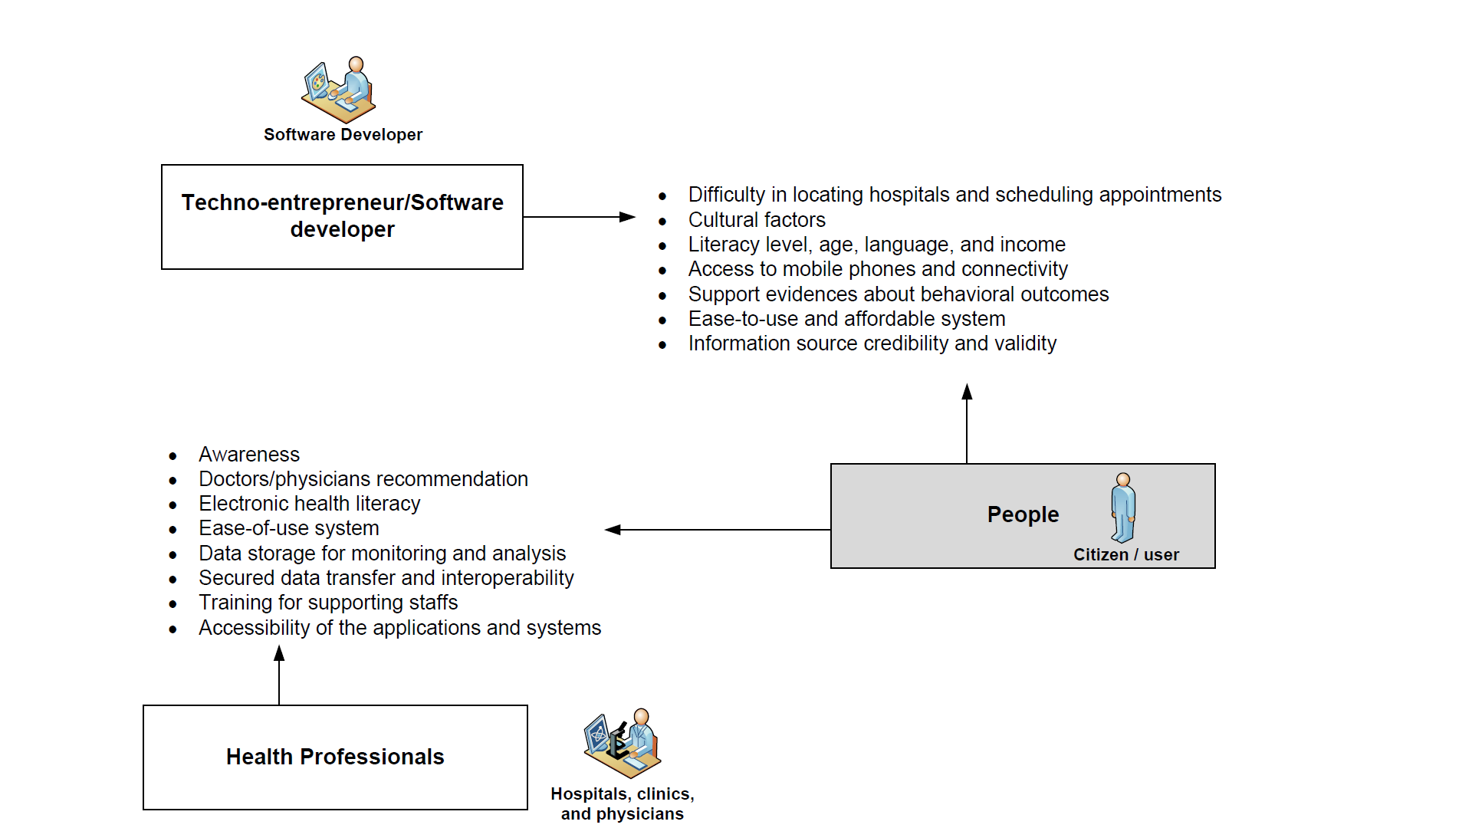

*Figure 2: A detailed account of the interactions that take place between individuals, medical experts, and software developers.*

Figure 2 illustrates how individuals, software entrepreneurs, and medical practitioners can work together to improve healthcare. When developing mobile health technologies and applications, it was discovered that companies in the technology sector should also take into consideration the demographic features and other cultural variables of the people they are targeting. The research also found that individuals who are self-aware of their health and take steps to improve it are more likely to adhere to their treatment plans and accurately follow their physicians' instructions on their medicine. They are finding that it is advantageous because the solutions for improving their health are simple, easy to use, and inexpensive.

During times of poor illness, patients and their families look to healthcare professionals for the architecture, personnel, resources, knowledge, and care they require. They also anticipate receiving a recommendation from healthcare professionals for the enhancement of awareness and the utilisation of the applications because of their concerns regarding the usability of the knowledge and the authenticity of the sources of the knowledge. This result has also been empirically corroborated, indicating that behavioural intention strongly affects both the perception of mobile health technology and applications for health*. (Sulis et al., 2021).*

The results of the study show that, additionally, the information and source credibility, for which the assistance of medical practitioners is essential in order to carry out action via cell devices. People choose diet and exercise programmes that give them the most up-to-date health information as well as things like gamification and incentive schemes to get them to exercise and do other forms of exercise.

# Cost savings in healthcare: -

Chronic conditions are costing the world economy billions of dollars every year. According to the Chronic Disease Prevention Alliance’s report in the United Nations, approximately 60% of developed nations' citizens have at least one chronic illness, and the remaining 80% are at risk of developing one.

The costs to the economy and to patients are enormous. Here are some more statistics from the UN resource mentioned above:

"Chronic illnesses directly cost the world economy $68 billion in healthcare costs."

This equates to a loss of $122 billion in indirect income and productivity for businesses. "

# Improvements in Healthcare Delivery Efficiency and Speed:

 It is reasonable to assume that mobile applications for healthcare will play a significant part in enabling patients to take charge of their own health care by utilising digitally enabled care pathways, broadening people's access to medical services, and raising ability to participate in and recognition of issues pertaining to the health and very well for the general population. It is almost inevitable that evidence-based health applications will be integrated into established clinical treatment pathways. The purpose of this integration will be to improve current treatment outcomes while also extending access to specialised and, where appropriate, individualised therapy. There is a possibility that using health applications could make the delivery of health care more environmentally friendly. They make it possible to do remote monitoring, therapy, and surgery, as well as remote management of medications, which can assist reduce the amount of time medical professionals need to spend travelling.

# Barriers and drawbacks for mHealth applications:

* Challenges and Obstacles in Implementation:
* Disparities between ICT culture and that of the medical community; the ingrained nature of medical institutions:

The confidentiality and protection of patient health records are perennial issues. An additional layer of uncertainty is introduced when a modern tech, like mobile, is introduced.

The ability to accept mHealth technology has been noted as a relatively low-hanging fruit contrasted to those other obstacles to its widespread to pay and a lack of value were identified by only one-half as many people as were other obstacles. Since elevated healthcare is valued and can be provided at a reasonable cost, services are scarce, mHealth can provide the possibility of serving as both a replacement for and in addition to more conventional services provided by medical professionals in person. *(Siegler et al., 2021)*

The tech industry says that the medical community is too slow to adopt new ways to use existing technologies. On the other hand, medical organisations and regulatory bodies are worried about the introduction of services and apps that haven't been proven to work and that are made by Silicon Valley companies that don't know much about how medicine works.

In order to stop this, it is important that regulatory systems and medical leadership work together to make sure that the risks and benefits of each mHealth service are balanced.

* The heterogeneity of the market might cause problems when implementing implementations. There is a risk that the most successful apps will not be the ones with the best features, but rather the ones whose creators have the most pervasive support layers for handling things like privacy, confidentiality, data, and networking assets.
* There is a proliferation of different mobile operating systems.
* Software incompatibility can be resolved temporarily through the use of apps on constrained fleets of devices, or through the use of web apps, voice, or SMS. Uniformity and interoperability between device manufacturers may help in the medium haul, and the informational burden for app adaptability will be big and powerful.
* Providing some electronic health records may necessitate additional work above the standard for the companies involved. Modifications in rules that make it possible for a national carrier to participate in the financial services industry could have positive effects on smartphone applications that include money transfers, for example, in the case.

For some creative apps to flourish, regulatory bodies need to take a cautious, practical look at the shifting marketplace.

## Service and hardware costs as a percentage of take-home pay:

* The price of smartphones capable of running helpful applications may limit their use to the well-off or to healthcare workers solely. Many useful and novel apps are now only available for use on smartphones. Help is at hand through the dispersion of subsidised handsets and the modification of software for relatively low-cost and cheaper mobile devices. It's predicted that cell phone prices will drop by a huge percentage over the next few years.

# Discussion and Results: -

The poll included both males and females from India and the United Kingdom, and it received a total of 27 replies.

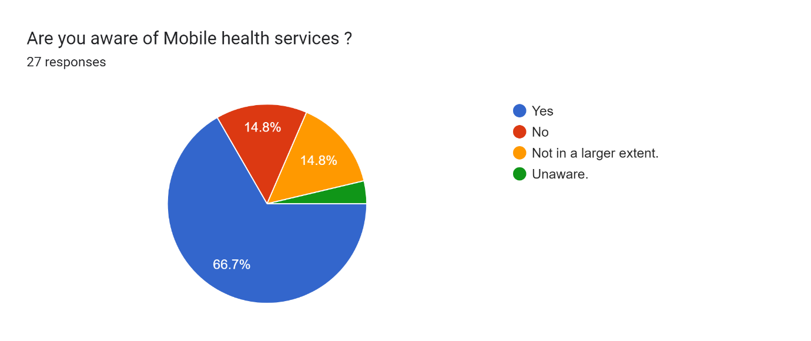

Figure 1:- percentage of participant having awareness about Mobile health applications.

Figure 1 provides a visual representation of the proportion of international survey participants having a brief idea and awareness about mobile health services. The answers were asked in 3 different opinions. Responses came primarily from yes (66.7%), no (14.8%), not in a larger extent (14.8%) and unaware (3.7%) with survey participants in the UK and India.

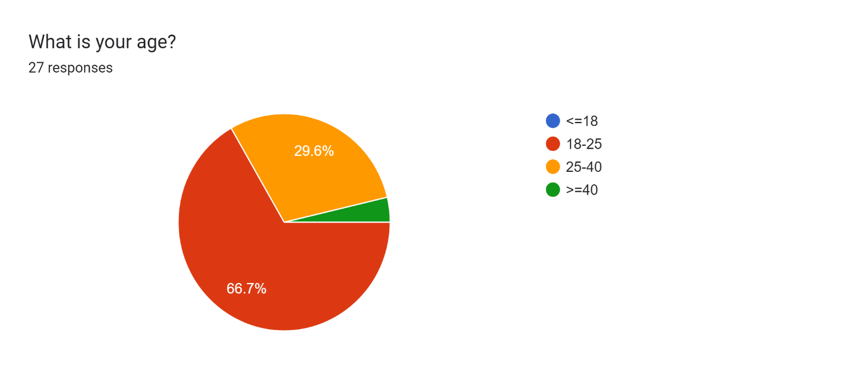

Figure 2 Age group of survey question responders

An age range of 18–25 was found among survey respondents. Figure 3 shows that participants from across the age spectrum took part in the survey, suggesting that there is no minimum age requirement for registering themselves or making themselves educated about an existing mobile health application. A registration with an existing mobile health application is available in both countries. There are 66.7% of participants who are within the age range of 18–25, 29.6% in the age range of 25–50, and 3.7% in the age range of 40+. No one below the age of 18 has responded so far. participants between the ages of 18 and 25 make up the largest demographic of survey respondents. Awareness about knowing mobile health applications do not discriminate based on gender.

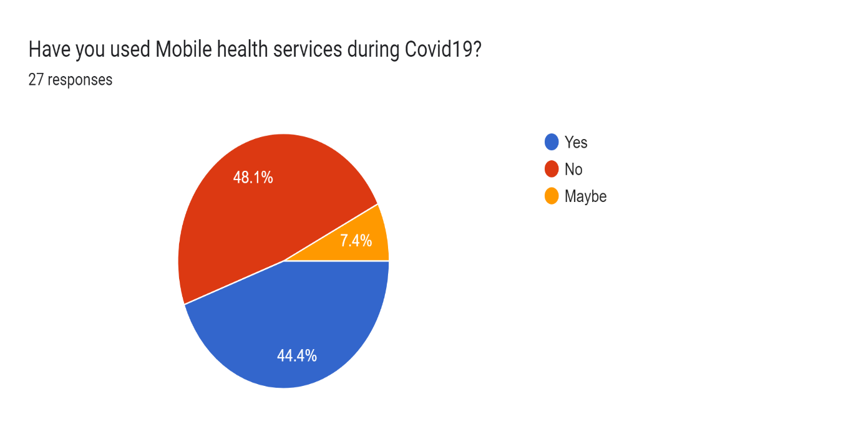

In Figure 3, it can be clearly seen that the amount of usage during the global COVID pandemic in the year of 2019 was one of the major factors for application makers to impose an excessive usage and profound reliance on health technology applications. Due to lack of knowledge and lack of awareness, only 44.6% of total participants have used mHealth applications, while the rest of the participants either did not have the idea or did not even know whether they’ve used these mHealth applications or not.

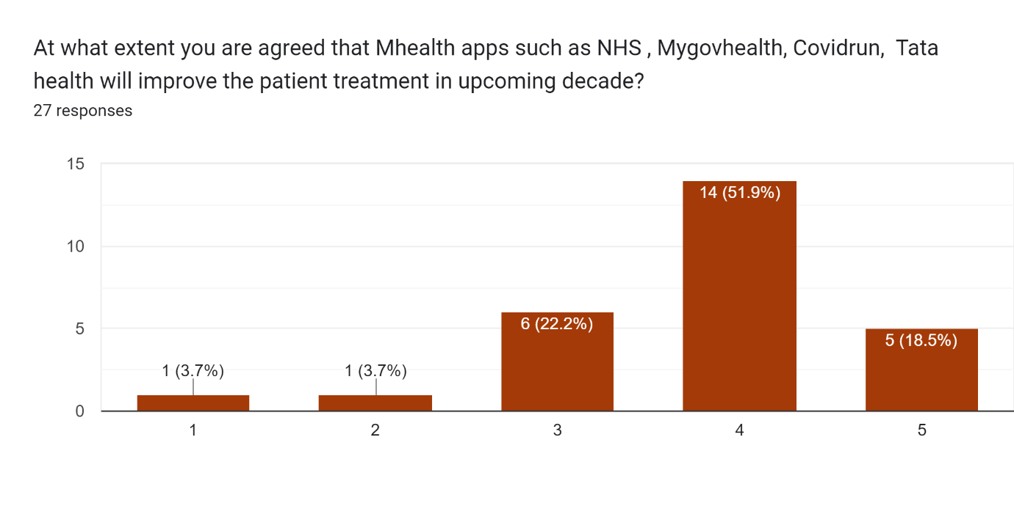

Figure 3 belief in mHealth applications for more effective treatment in upcoming decade

On the above bar graph, the data presented is derived from various opinions and answers from survey participants. In this data, it can be clearly seen that trust and belief on treatment and consultation through mHealth applications are derived from various opinions and answers from participants. Based on the results of a survey, the information in the bar chart above shows that most people (51%) have a positive view of the latest way to treat health problems using mobile apps, which is expected to have an impact in the next ten years, while only a small percentage (4.6%) have a negative view.

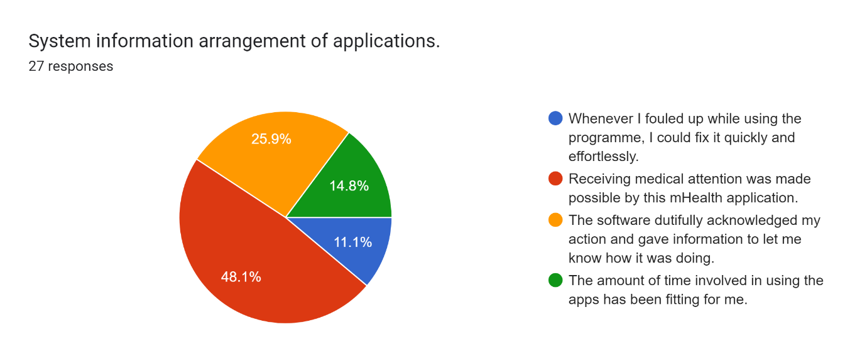

 Figure 4 system information arrangements of applications

During the course of carrying out a survey, it can be clearly seen that the participants' overall understanding of the system information arrangements of the mobile health applications has multiple layers of improvements. The above pie chart has significant data of understanding about how the participants have effectively used the application, where 48.1% of the participants showed their adoptive approach and found out that receiving medical attention was made possible by the cutting-edge mobile health applications. On the flip side, only 11.1% of the participants showed that they could conduct a modification in the application for creating a customised consultation and the information that they wanted to acquire from the system.

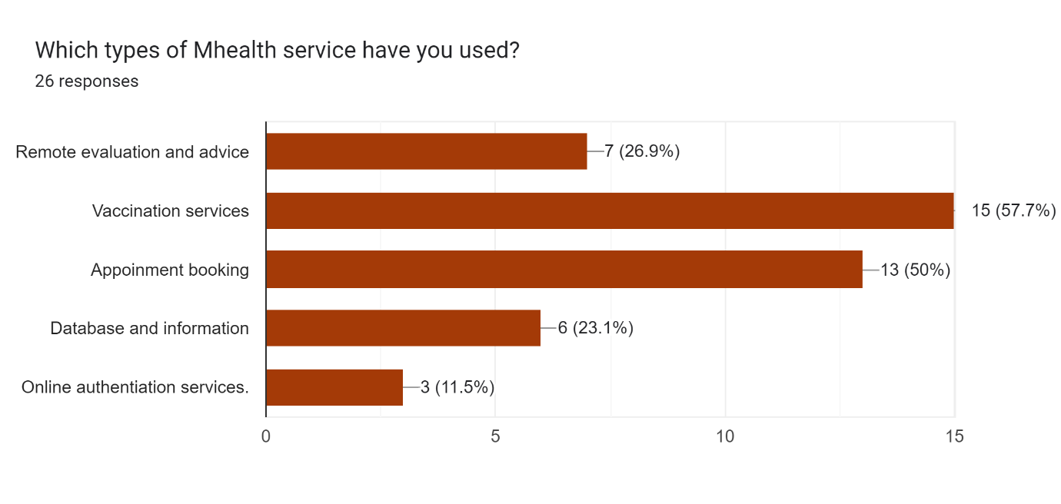

Figure 5 various purpose for using mHealth applications by the survey participants.

During the time of survey conduction, as the horizontal bar chart shows, most survey participants (57.7%) have put their vote for using any mHealth application for the general purpose of vaccination service during the COVID-19 pandemic era. The result clearly shows the proportion of mHealth applications which can be used for common problems, e.g., mass vaccination programmes, vaccination appointment bookings, universal newsletter announcements, and online authentication services as well. Another fact which can be derived from the above survey is that during a global pandemic like the novel coronavirus disease which occurred in 2019, these cutting-edge digitised technologies can be widely used as a source of information which can be controlled by official organisations.

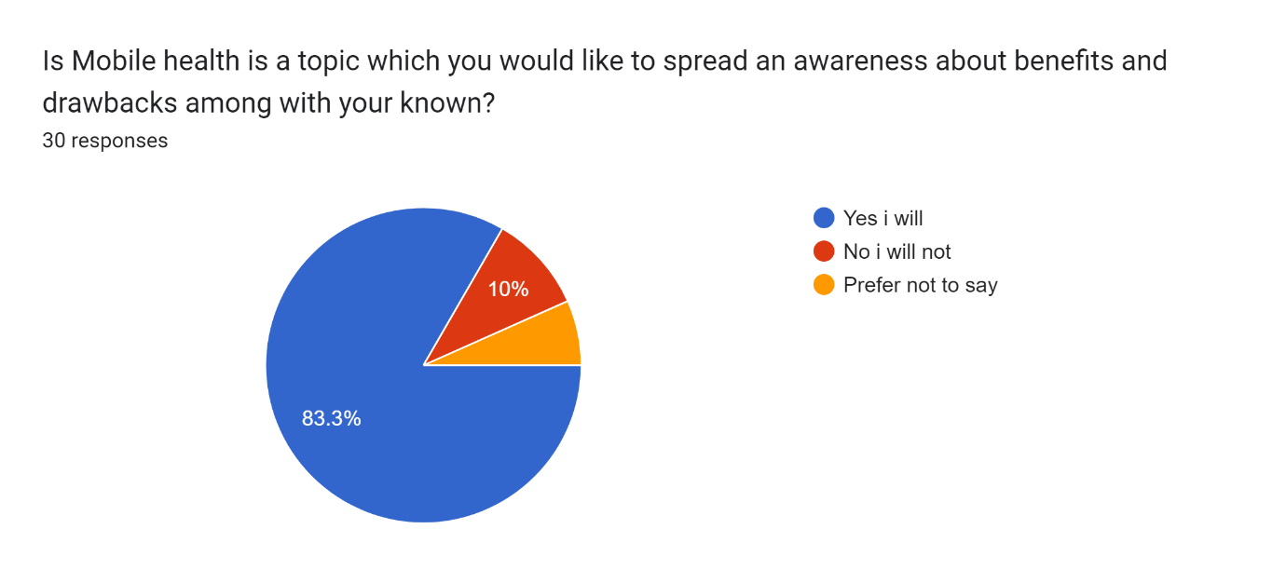

Figure 6 Participants about their opinion on spreading mHealth application feedback.

To understand how mobile health applications have been performed and delivered the desired results for an individual participant, it’s an important factor to be understood by the participants about their novel duty of spreading awareness about the mHealth applications which they’ve used so far. As per the survey result, it can be clearly seen that most participants ( 83.3%) have shown their interest in spreading awareness and positive outcomes about their personal experience with using mHealth applications. whereas only 10% of participants have given a negative vote on spreading awareness about new mobile health applications.

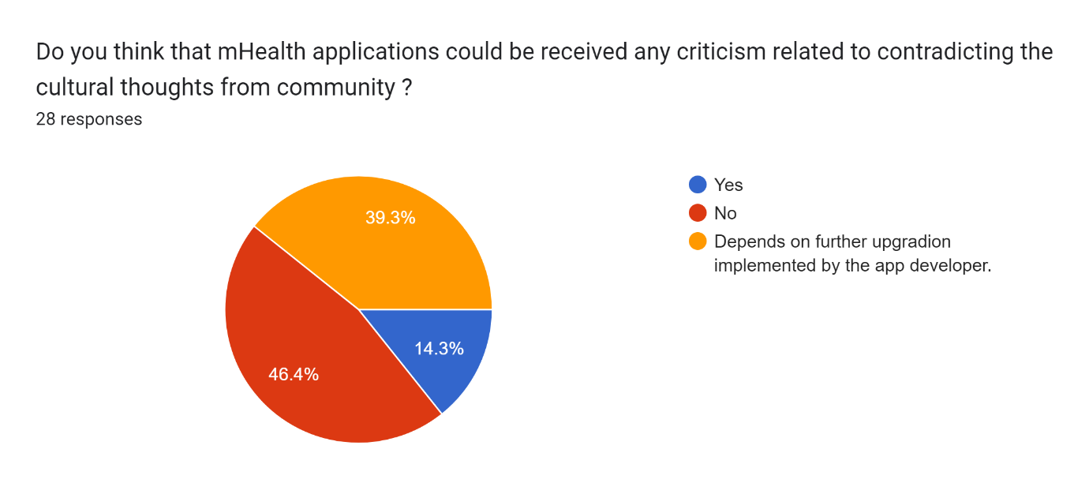

*Figure 9 shows the social impact of using mHealth on a daily basis.*

Social consequences are frequently experienced as a result of the less effective and biased outcomes predicted by mobile health applications. It is an important prospect for software developers and policymakers to hold and look for cultural and community effects from using mobile health applications. Biased results and inaccurate health analytics may create chaos for the specific community. In the above graph, it can be clearly seen that a fair number of participants (46.6%) had not received any biased or inaccurate things while using mHealth applications. On the flip side, barely 14.3% of total participants had observed a possibility of cultural thought violation and biased outcomes from their usage of mHealth applications. whereas major participants have shown their interest in giving suggestions on further upgradation and major implementation by the application developer.

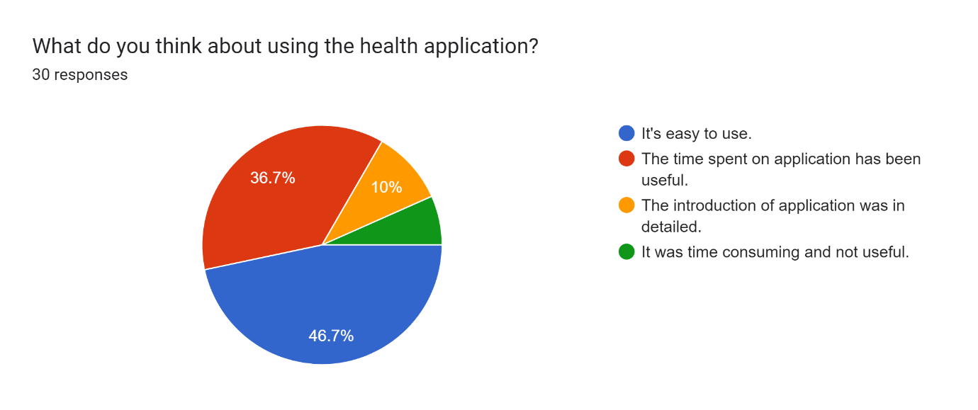

*Figure 10: Participants' response to Using mHealth Applications*

When asked participants about their own experience of using mobile health applications on an individual level, the highest number of votes for ease of using mobile health applications has been received, as it clearly justifies that good user experience and attractive user interaction can create and attract more people to transfer themselves for using and adapting these digitised health applications. On the other hand, the response of mHealth applications' usefulness and its introduction have also received positive responses (36.7%) and (10%) from the survey participants. From the developers' point of view, it is extremely important to keep the application’s user experience (UX) and user interaction (UI) in a user-friendly manner for getting better results and data gathering.

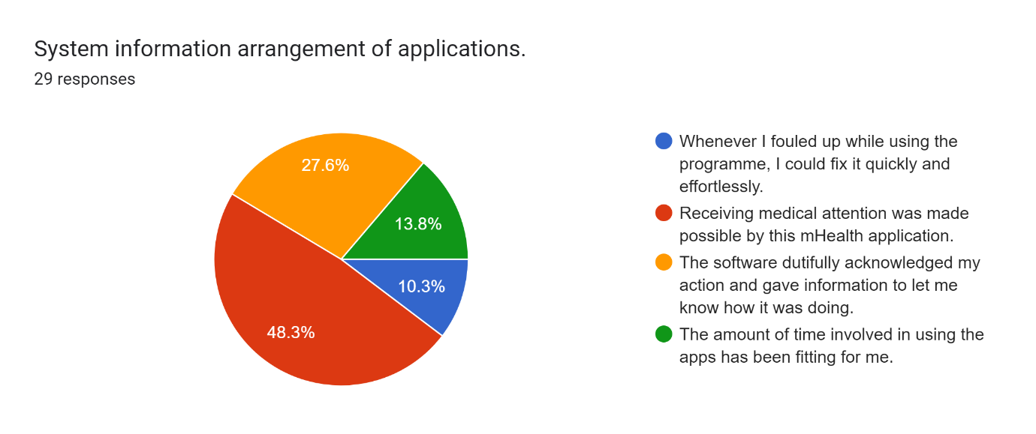

*Figure 11: Responses of participants to application information arrangements*

Every application needs an information arrangement in terms of providing clear information to their users, which they are looking for. It is an application developer’s responsibility to create a microservice data structure and server connection to provide quick and easy access to their individual use of applications. From Figure 9’s pie chart, almost half of the survey participants have given their vote for getting appropriate medical attention being made possible because of mHealth applications. Inclusion of 27.6% of participants assumed to have knowledge of digitalized healthcare have voted in personalised recommendations based on cookie catching by applications. In terms of overall data collections, it is clear that receiving medical attention and productive time spent with mHealth applications creates a wide user range.

* Candidates’ activeness and their level of contentment with it: -

According to the findings of the research, it can be concluded that in-person engagement with the application is more effective than remote instructions and consultation. In order to make it easy for the application developers who can create the application for easy-to-use, easy-to-access and state of the art creation of the multipurpose application, it can impact a very broad area where the services can be made available for all age group users for their own needs.

# Findings and recommendations: -

It is possible for a mobile health application to be geared towards clients or their families, health care professionals, or even healthy people who are interested in preventive care. It is essential to gain an understanding not just of the demographics of the target group, such as their socioeconomic background and educational level, in addition to their hopes and fears. In order to create a client mobile health application, each of these questions must be addressed. It is essential to take into consideration the Internet connectivity and multimedia capabilities of the mobile device that will be used to access the application. Most low-income Indians now access services through mobile phones rather than any other device. It may be advantageous in some other nations to be able to obtain information in order to view it when not connected to the internet. When planning usability, the app developer must always plan for the worst-case situation in terms of sudden expansion.

# The project's constraints: -

Participants from the United Kingdom and India took part in the research project; hence, only those two nations are represented among the participants. As a result, interpreted from the survey, very few respondents were from the United Kingdom, from the overall response. As a result, understanding and interpretation among respondents from the United Kingdom for mHealth applications are not fully clear, and because of that, the final responses from the survey are being centred on responses from India. In addition to investigating their points of view on how to get over the challenges they face, a poll based on our findings ought to be carried around the region or the country to guarantee that its applicability may be generalised. The outcomes, regardless of the limitations of the study, reveal valuable insight into the efficacy of mobile health adaption in both the United Kingdom and India. Moreover, on observing current developments in existing mobile health technologies in India, the interpretation of upcoming updates is still questionable. As a result, the limitations, findings, and interpretations in this report have a significant impact on the overall working and adapting framework of mobile health applications.

Future works: -

This research's use cases include improving the current supply chain from the standpoint of mHealth applications like Tata-1mg, distributing life-saving drugs, and storing an adequate amount of essential medicine stocks in preparation for the next possible pandemic or major medical emergency. It is possible to automatically detect spikes in these search phrases using a prediction model trained on the historical searches and searches as a leading feature in a time series model. This can help make sure that the right number of important medicines are stored in the right warehouses, based on how much demand is expected.

In addition to performing medical searches, giving online consultations on specified medical conditions, and delivering prescriptions to patients' doors, the mHealth application also performs a battery of essential tests, such as RT-PCR and antigen testing. Because each major player in mHealth applications processes over 10 million prescription and non-prescription orders annually in India, there is also a wealth of prescription data, both handwritten and digital. A prescription includes the patient's name, age, and gender, as well as the prescribing physician's name, address, phone number, and email address, as well as instructions on how often, for how long, and what medication(s) should be taken. This information may be de-identified, pooled, and examined across demographic categories. If all this data was stored in a structured manner, it could be positively used to improve and enhance the outcomes for individuals who use such mHealth applications. This is an area of improvement that may cause fewer deaths and more good healthcare services for consumers. *(Lipscomb et al., 2021)*

The application interaction plans should be created with less mental strain and more engagement, where the app support team should receive training in the use of online modalities for keeping the application running smoothly. The rapidly expanding field of mHealth provides a springboard for experimentation and cutting-edge developments in the collection of patient health data, opening up novel opportunities for the promotion of healthy living. Apple Inc., Google Inc., and Samsung Group (SAMSUNG, Suwon, South Korea) are just a few of the big tech firms that have included cutting-edge methods for health activity tracking in the creation of their flagship handsets. (Ma and Liu, 2022)

The HealthKitTM platform from Apple serves as a hub for all of a user's health data, including readings from fitness trackers, blood pressure monitors, and other related apps. Apple is also collaborating with large-scale electronic medical record systems like Epic and Cerner to include their software with HealthKit. Focus Motion is one company broadening the scope of physical activity quantification beyond counting steps to include activities like weightlifting and yoga. Although the accuracy of heart rate data for tracking performance and calorie consumption has not been verified in peer-reviewed research, more and more popular wristband gadgets are beginning to offer this feature. When it comes to tracking your heart rate while you work out, "smart clothing" is a new concept that lets you get continuous data from your chest and is often more accurate than sensors on your wrists. (Ma and Liu, 2022)

For instance, to offer early warning indications by monitoring the autonomic nervous system in real-time, mHealth technologies are increasingly being used in translational healthcare research settings. However, this promise will not be fulfilled until infrastructure modifications make it possible for such data to synchronise with EMRs and the healthcare system as a whole. For mHealth data streams to be used in clinical decision-making, existing technologies would need to be validated and standardized, and mHealth data streams would need to be integrated.

# Conclusion:

Levels of Knowledge and Application of Mobile Health:

 The approach that was taken to accomplish the major objective of the study, which was to determine the level of awareness and the extent to which mobile health was utilised, consisted of two distinct parts, both of which are supported by hypotheses. The purpose of the study was to ascertain the degree to which mobile health has been adopted in India. The purpose of the first section of this article was to conduct a comparative analysis to investigate the significant difference and magnitude of effect between of awareness level in the use of mobile phones for health communication and delivery, and self-management of health applications between scientific and continuing to work staff, medical and health professionals, and others who participated in the universal survey to understand the overall understanding of mobile health. This was done in order to determine whether or not there is a significant difference in the awareness level in the use of mobile phones for health communication and delivery, and whether or not It has been established that the significance of the elements that determine both consciousness and intent to utilise.

The survey participants have stated that they use their mobile phones for their health care via interaction with mobile health apps that are relevant to their health and communicate with their physicians through the use of video calling, calling, and text messaging apps. This suggests that the information that is available online is physically accessible to a considerable extent; nevertheless, awareness of its existence is lacking. However, in certain instances, problems have been identified among the responders. These problems happen because the patients or users may not be able to tell if the information is real or if the language used by the sender is hard for them to understand.

The replies were collected from working professionals, students, and senior citizens from two nations using the Google Forms service, and then the findings were reviewed.

According to the findings of this survey, it shows that the results of a poll asking respondents to express one of three perspectives on the extent to which they were acquainted with mobile medical services. Participants in the UK and India predominantly answered "yes" (66.7%), "no" (14.8%), "not to a greater extent" (14.8%), and "unaware" (3.7%) to the survey questions. This demonstrates that the vast majority of participants are aware of medical applications.

Participants in the poll ranged in age from 18 to 25. As can be seen in the survey results, respondents to the survey came from a wide range of ages, demonstrating that there is no minimum age restriction for enrolling in or learning about one of the many existing mobile health applications accessible in the two nations. Sixty-seven percent of respondents are between the ages of 18 and 25, 29.6 percent are between the ages of 25 and 50, and 3.7 percent are 40 and older. This result shows that the age group between 18 and 25 has the highest understanding of usage and implementation of mobile health applications.

Most respondents (56.7%) voted in favour of using any mHealth application for the general purpose of vaccination service during the COVID-19 pandemic era, as shown by the horizontal bar chart. This result clearly shows the proportion of mHealth applications that can be used for common problems like mass vaccination programmes, vaccination appointment bookings, Pervasive Bulletin declarations, and online verification services. It is also clear from the data collected above that these modern digital platforms can be put to widespread use as a source of facts that can be regulated by government bodies in the event of a worldwide pandemic, such as the novel coronavirus disease that emerged in 2019.

mHealth could transform India's healthcare system. by addressing rural healthcare needs and improving city residents' access to care. We provide frameworks and methodologies for expanding mHealth's impact in underserved communities, including cities. Due to their proximity to patients, telecommunications corporations are projected to play a big role in mobile health care in India. owning their networks' hardware and software.

# Appendices:

According to the project's goal, I created the following survey for various age group participants who have used any mobile health applications in India and the United Kingdom.

- Questionnaire: -

* Are you aware of mobile health services?

1. Yes
2. No
3. Not to a greater extent
4. Unaware

* Have you used mobile health services during the COVID-19 pandemic?

1. Yes
2. No
3. may be

* What is your gender?

1. Male
2. Female
3. I prefer not to say

* What is your age?

1. <=18
2. 18-25
3. 25-40
4. >=40

* Is mobile health a topic on which you would like to spread awareness about the benefits and drawbacks among your acquaintances?

1. Yes, I will
2. No, I will not
3. I prefer not to say

* How confident are you that mHealth apps like NHS, Mygovhealth, Covidrun, and Tata Health will improve patient care in the coming decade?
* Options for answers were given in numbers from 1 to 5.
* Do you think that mHealth applications could receive any criticism related to contradicting the cultural thoughts of the community?

1. Yes
2. No
3. It depends on further upgradation implemented by the app developer.

* What do you think about using the health application?

1. It is easy to use.
2. The time spent on applications has been useful.
3. The introduction of the application was in detail.
4. It was time-consuming and not useful.

* System information arrangement of the application

1. Whenever I messed up while using the programme, I could fix it quickly and effortlessly.
2. Receiving medical attention was made possible by this mHealth application.
3. The software dutifully acknowledged my actions and gave me information to let me know how it was going.
4. The amount of time involved in using the apps has been perfect for me.

* Medical care you would have normally received in-person

1. Satisfied
2. Excellent
3. Observed room for improvement.

* Which types of mHealth services have you used?

1. Remote evaluation and advice
2. Vaccination services
3. Appointment booking
4. The database and information
5. Online authentication services

# References: -

* Ventola, C.L. (2019). Mobile Devices and Apps for Health Care Professionals: Uses and Benefits. *P & T : a peer-reviewed Journal for Formulary Management*, [online] 39(5), pp.356–64. Available at: https://www.ncbi.nlm.nih.gov/pmc/articles/PMC4029126/.

‌

* Sulis, G., Batomen, B., Kotwani, A., Pai, M. and Gandra, S. (2021). Sales of antibiotics and hydroxychloroquine in India during the COVID-19 epidemic: An interrupted time series analysis. *PLOS Medicine*, 18(7), p.e1003682. doi:10.1371/journal.pmed.1003682.

‌

* Nurgalieva, L., O’Callaghan, D. and Doherty, G. (2020). Security and Privacy of mHealth Applications: A Scoping Review. *IEEE Access*, 8(ddrh78432), pp.104247–104268. doi:10.1109/access.2020.2999934.
* ‌Nouri, R., R Niakan Kalhori, S., Ghazisaeedi, M., Marchand, G. and Yasini, M. (2018). Criteria for assessing the quality of mHealth apps: a systematic review. *Journal of the American Medical Informatics Association*, [online] 25(8), pp.1089–1098. doi:10.1093/jamia/ocy050.
* ‌Müthing, J., Brüngel, R. and Friedrich, C.M. (2019). Server-Focused Security Assessment of Mobile Health Apps for Popular Mobile Platforms. *Journal of Medical Internet Research*, 21(1), p.e9818. doi:10.2196/jmir.9818.

‌

* Mulder, T. and Tudorica, M. (2019). Privacy policies, cross-border health data and the GDPR. *SSRN Electronic Journal*, 12.66(12.66). doi:10.2139/ssrn.3506786.
* ‌ltd, R. and M. (n.d.). *India Mhealth Market - Forecasts from 2021 to 2026*. [online] www.researchandmarkets.com. Available at: https://www.researchandmarkets.com/reports/5397929/india-mhealth-market-forecasts-from-2021-to-2026.

‌

* Lipscomb, M.M., Mohammad, A., Abdulrahman, A. and Jololian, L. (2021). Value-based modeling for mobile health application development. *mHealth*, 0(vv34lp9). doi:10.21037/mhealth-21-32.

‌

* Huang, C.-Y. and Kao, Y.-S. (2015). *UTAUT2 Based Predictions of Factors Influencing the Technology Acceptance of Phablets by DNP*. [online] Mathematical Problems in Engineering. Available at: https://www.hindawi.com/journals/mpe/2015/603747/.

‌

* Gupta, M. and Soeny, K. (2021). Algorithms for rapid digitalization of prescriptions. *Visual Informatics*, 22. doi:10.1016/j.visinf.2021.07.002.

‌

* delloite (n.d.). *How Digital Health Apps are Empowering Patients*. [online] Deloitte United States. Available at: https://www2.deloitte.com/us/en/blog/health-care-blog/2021/how-digital-health-apps-are-empowering-patients.html.

‌

* Dalal, H. (n.d.). *Mobile Health (mHealth) Industry SWOT Analysis, Size, Share, Price, Trends and Growth Forecast to 2025*. iCrowdNewswire.https://icrowdnewswire.com/2021/01/28/mobile-health-mhealth-industry-swot-analysis-size-share-price-trends-and-growth-forecast-to-2025/ [Accessed 29 Sep. 2022].
* Holdener, M., Gut, A. and Angerer, A. (2020). Applicability of the User Engagement Scale to Mobile Health: A Survey-Based Quantitative Study. *JMIR mHealth and uHealth*, 8(1), p.e13244. doi:10.2196/13244.
* Nurgalieva, L., O’Callaghan, D. and Doherty, G. (2020). Security and Privacy of mHealth Applications: A Scoping Review. *IEEE Access*, 8(ddrh78432), pp.104247–104268. doi:10.1109/access.2020.2999934.
* Ma, R. and Liu, B. (2022). Analysis of Factors Influencing the Development of mHealth Innovation Based on Data Mining Algorithms. *Mathematical Problems in Engineering*, 2022(c 15), pp.1–13. doi:10.1155/2022/4311937.
* Siegler, A.J., Knox, J., Bauermeister, J.A., Golinkoff, J., Hightow-Weidman, L. and Scott, H. (2021). Mobile app development in health research: pitfalls and solutions. *mHealth*, 7(4), pp.32–32. doi:10.21037/mhealth-19-263.
* Smith, C. (2018). Healthcare IT market size, market growth and competitive analysis, industry forecasts to 2026. *Journal of Developing Drugs*, 07(c16h12). doi:10.4172/2329-6631-c1-027.
* Das, S. and Sil, J. (2019). Managing uncertainty in imputing missing symptom value for healthcare of rural India. *Health Information Science and Systems*, 7(1). doi:10.1007/s13755-019-0066-4.
* Amer, S.A., Bahumayim, A., Shah, J., Aleisa, N., Hani, B.M. and Omar, D.I. (2022). Prevalence and Determinants of Mobile Health Applications Usage: A National Descriptive Study. *Frontiers in Public Health*, 10. doi:10.3389/fpubh.2022.838509.
* S, H. (2020). COVID-19 DATA ANALYSIS AND DATA VISUALIZATION. *International Journal of Engineering Applied Sciences and Technology*, 5(4), pp.267–271. doi:10.33564/ijeast.2020.v05i04.040.
* Sulis, G., Batomen, B., Kotwani, A., Pai, M. and Gandra, S. (2021). Sales of antibiotics and hydroxychloroquine in India during the COVID-19 epidemic: An interrupted time series analysis. *PLOS Medicine*, 18(7), p.e1003682. doi:10.1371/journal.pmed.1003682.

‌

‌